Neeraj Appari S073

Prac9:

Aim: Create an android app to save user data in a database and use of different queries.

XML

<?xml version="1.0" encoding="utf-8"?>

<RelativeLayout xmlns:android="http://schemas.android.com/apk/res/android"

xmlns:app="http://schemas.android.com/apk/res-auto"

xmlns:tools="http://schemas.android.com/tools"

android:layout_width="match_parent"

android:layout_height="match_parent"

android:orientation="vertical"

tools:context=".MainActivity">

<EditText

android:id="@+id/eroll"

android:layout_width="wrap_content"

android:layout_height="wrap_content"

android:layout_alignParentTop="true"

android:layout_alignParentEnd="true"

android:layout_alignParentRight="true"

android:layout_marginTop="79dp"

android:layout_marginEnd="18dp"

android:layout_marginRight="18dp"

android:ems="10"

android:inputType="textPersonName" />

<EditText

android:id="@+id/editTextTextPersonName"

android:layout_width="wrap_content"

android:layout_height="52dp"

android:layout_alignParentTop="true"

android:layout_alignParentEnd="true"

android:layout_marginTop="19dp"

android:layout_marginEnd="111dp"

android:background="@drawable/ic_launcher_background"

android:backgroundTint="#531C1C"

android:ems="10"

android:inputType="textPersonName"

android:textColor="@color/white" />

<TextView

android:id="@+id/textView3"

android:layout_width="71dp"

android:layout_height="38dp"

android:layout_alignParentStart="true"

android:layout_alignParentLeft="true"

android:layout_alignParentTop="true"

android:layout_marginStart="77dp"

android:layout_marginLeft="77dp"

android:layout_marginTop="89dp"

android:text="Roll No:" />

<TextView

android:id="@+id/textView4"

android:layout_width="62dp"

android:layout_height="29dp"

android:layout_alignParentStart="true"

android:layout_alignParentLeft="true"

android:layout_alignParentTop="true"

android:layout_marginStart="76dp"

android:layout_marginLeft="76dp"

android:layout_marginTop="151dp"

android:text="Marks:" />

<EditText

android:id="@+id/edmarks"

android:layout_width="wrap_content"

android:layout_height="wrap_content"

android:layout_alignParentTop="true"

android:layout_alignParentEnd="true"

android:layout_alignParentRight="true"

android:layout_marginTop="135dp"

android:layout_marginEnd="21dp"

android:layout_marginRight="21dp"

android:ems="10"

android:inputType="textPersonName" />

<Button

android:id="@+id/badd"

android:layout_width="match_parent"

android:layout_height="wrap_content"

android:layout_alignParentBottom="true"

android:layout_marginBottom="475dp"

android:text="Add Record" />

<Button

android:id="@+id/btupd"

android:layout_width="match_parent"

android:layout_height="wrap_content"

android:layout_alignParentBottom="true"

android:layout_marginBottom="409dp"

android:text="Update Record" />

<Button

android:id="@+id/bdel"

android:layout_width="match_parent"

android:layout_height="wrap_content"

android:layout_alignParentBottom="true"

android:layout_marginBottom="328dp"

android:text="Delete Record" />

<Button

android:id="@+id/btnsearch"

android:layout_width="match_parent"

android:layout_height="wrap_content"

android:layout_alignParentBottom="true"

android:layout_marginBottom="264dp"

android:text="Search Record" />

<Button

android:id="@+id/btnclear"

android:layout_width="match_parent"

android:layout_height="wrap_content"

android:layout_alignParentBottom="true"

android:layout_marginBottom="205dp"

android:text="Clear" />

<Button

android:id="@+id/bview"

android:layout_width="match_parent"

android:layout_height="wrap_content"

android:layout_alignParentBottom="true"

android:layout_marginBottom="118dp"

android:text="Display All Record" />

</RelativeLayout>

package com.example.databasep9;

import androidx.appcompat.app.AlertDialog;

import androidx.appcompat.app.AppCompatActivity;

import android.database.Cursor;

import android.os.Bundle;

import android.view.View;

import android.widget.Button;

import android.widget.EditText;

import android.widget.Toast;

public class MainActivity extends AppCompatActivity {

DatabaseHelper mydb;

EditText e1,e2;

Button btn_add,btn_view,btn_upd,btn_del,btn_clr, btn_src;

@Override

protected void onCreate(Bundle savedInstanceState)

{

super.onCreate(savedInstanceState);

setContentView(R.layout.activity_main);

mydb = new DatabaseHelper(this);

e2 = findViewById(R.id.edmarks);

e1 = findViewById(R.id.eroll);

btn_add = findViewById(R.id.badd);

btn_view = findViewById(R.id.bview);

btn_upd = findViewById(R.id.btupd);

btn_del = findViewById(R.id.bdel);

btn_clr = findViewById(R.id.btnclear);

btn_src = findViewById(R.id.btnsearch);

btn_clr.setOnClickListener(new View.OnClickListener()

{

@Override

public void onClick(View v)

{

e1.setText("");

e2.setText("");

}

});

btn_src.setOnClickListener(new View.OnClickListener()

{

@Override

public void onClick(View v)

{

Cursor cs = mydb.search(e1.getText().toString());

if (cs.getCount() == 0)

{

showmesage("error","nothing found");

Toast.makeText(getApplicationContext(), "No record", Toast.LENGTH_LONG).show();

return;

}

else

{

StringBuffer bf = new StringBuffer();

while (cs.moveToNext()) {

bf.append("Roll No:" + cs.getString(0) + "\n");

bf.append("MARKS:" + cs.getString(1) + "\n");

}

showmesage("data", bf.toString());

}

}

});

btn_del.setOnClickListener(new View.OnClickListener()

{

@Override

public void onClick(View view)

{

int c = mydb.deleteData(e1.getText().toString());

if(c >0)

Toast.makeText(getApplicationContext(), c+"record deleted", Toast.LENGTH_LONG).show();

else

Toast.makeText(getApplicationContext(), "record not found", Toast.LENGTH_LONG).show();

}

});

btn_upd.setOnClickListener(new View.OnClickListener()

{

@Override

public void onClick(View view)

{

boolean ch= mydb.updateData(e1.getText().toString(),e2.getText().toString());

if(ch == true)

Toast.makeText(getApplicationContext(), "record updated", Toast.LENGTH_LONG).show();

else

Toast.makeText(getApplicationContext(), "record not updated", Toast.LENGTH_LONG).show();

}

});

btn_add.setOnClickListener(new View.OnClickListener()

{

@Override

public void onClick(View view) {

boolean chk = mydb.insertData(e1.getText().toString(), e2.getText().toString());

if (chk == true) {

Toast.makeText(getApplicationContext(), "record inserted", Toast.LENGTH_LONG).show();

} else {

Toast.makeText(getApplicationContext(), "record not inserted", Toast.LENGTH_LONG).show();

}

}

});

btn_view.setOnClickListener(new View.OnClickListener() {

@Override

public void onClick(View view)

{

Cursor cs = mydb.getAllData();

if (cs.getCount() == 0)

{

showmesage("error","nothing found");

Toast.makeText(getApplicationContext(), "No record", Toast.LENGTH_LONG).show();

return;

}

else

{

StringBuffer bf = new StringBuffer();

while (cs.moveToNext()) {

bf.append("ID:" + cs.getString(0) + "\n");

bf.append("MARKS:" + cs.getString(1) + "\n");

}

showmesage("data",bf.toString());

}

}

});

}

public void showmesage(String title, String message)

{

AlertDialog.Builder ab = new AlertDialog.Builder(this);

ab.setCancelable(true);

ab.setTitle(title);

ab.setMessage(message);

ab.show();

}}

package com.example.databasep9;

import android.content.ContentValues;

import android.content.Context;

import android.database.Cursor;

import android.database.sqlite.SQLiteDatabase;

import android.database.sqlite.SQLiteOpenHelper;

public class DatabaseHelper extends SQLiteOpenHelper

{

public static final String DATABASE_NAME ="college.db";

public static final String TABLE_NAME ="result";

public static final String COL1 ="ROLLNO";

public static final String COL2 ="MARKS";

public DatabaseHelper(Context context)

{

super(context, DATABASE_NAME, null, 1);

}

@Override

public void onCreate(SQLiteDatabase db)

{

db.execSQL("CREATE TABLE "+TABLE_NAME+"("+COL1+" INTEGER PRIMARY KEY ,"+COL2+" TEXT )");

}

@Override

public void onUpgrade(SQLiteDatabase db, int i, int i1)

{

db.execSQL("DROP TABLE IF EXISTS "+TABLE_NAME);

onCreate(db);

}

public boolean insertData(String rollno, String marks)

{

SQLiteDatabase db = this.getWritableDatabase();

ContentValues cv = new ContentValues();

cv.put(COL1,rollno);

cv.put(COL2,marks);

long result = db.insert(TABLE_NAME,null,cv);

if(result == -1)

return false;

else

return true;

}

public Cursor getAllData()

{

SQLiteDatabase db = this.getWritableDatabase();

Cursor cs = db.rawQuery("SELECT * FROM "+TABLE_NAME,null);

return cs;

}

public Cursor search(String rollno)

{

SQLiteDatabase db = this.getWritableDatabase();

Cursor cs = db.rawQuery("Select * from "+TABLE_NAME+" where rollno ="+rollno,null);

return cs;

}

public boolean updateData(String rn, String marks )

{

SQLiteDatabase db = this.getWritableDatabase();

ContentValues cv = new ContentValues();

cv.put(COL2,marks);

db.update(TABLE_NAME,cv,"rollno="+rn, null);

return true;

}

public int deleteData(String rollno)

{

SQLiteDatabase db = this.getWritableDatabase();

int cn = db.delete(TABLE_NAME,"rollno="+rollno,null);

return cn;

}

}

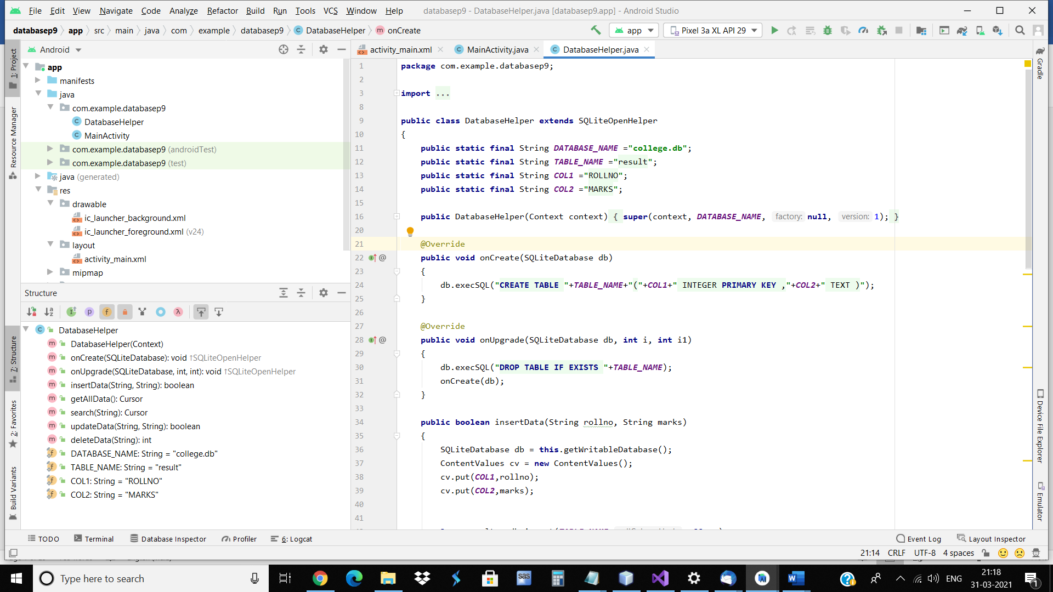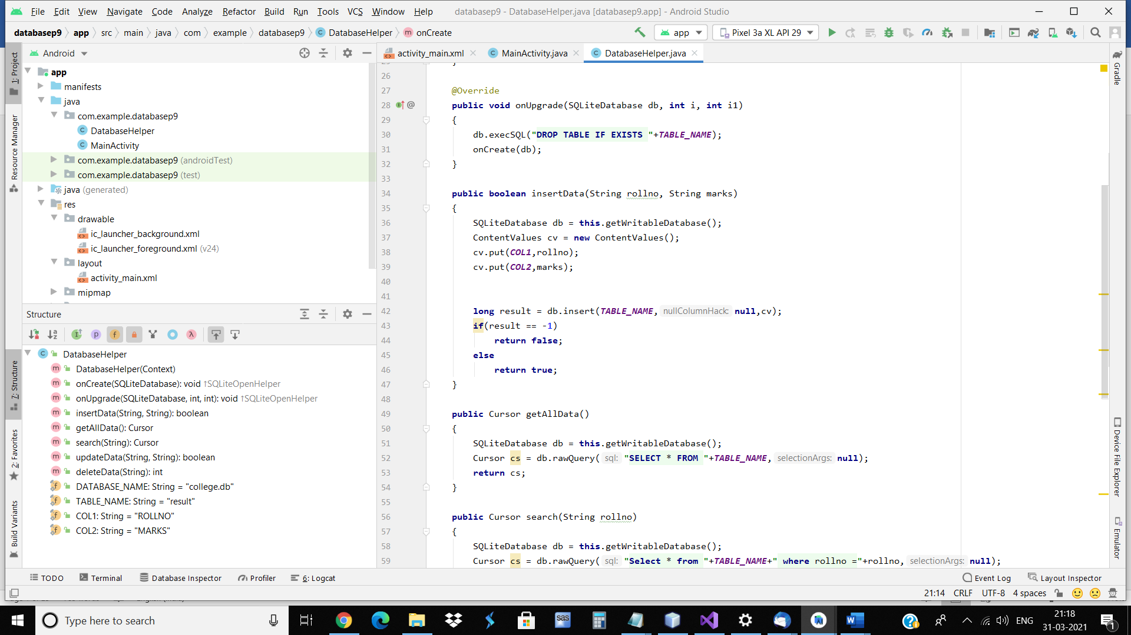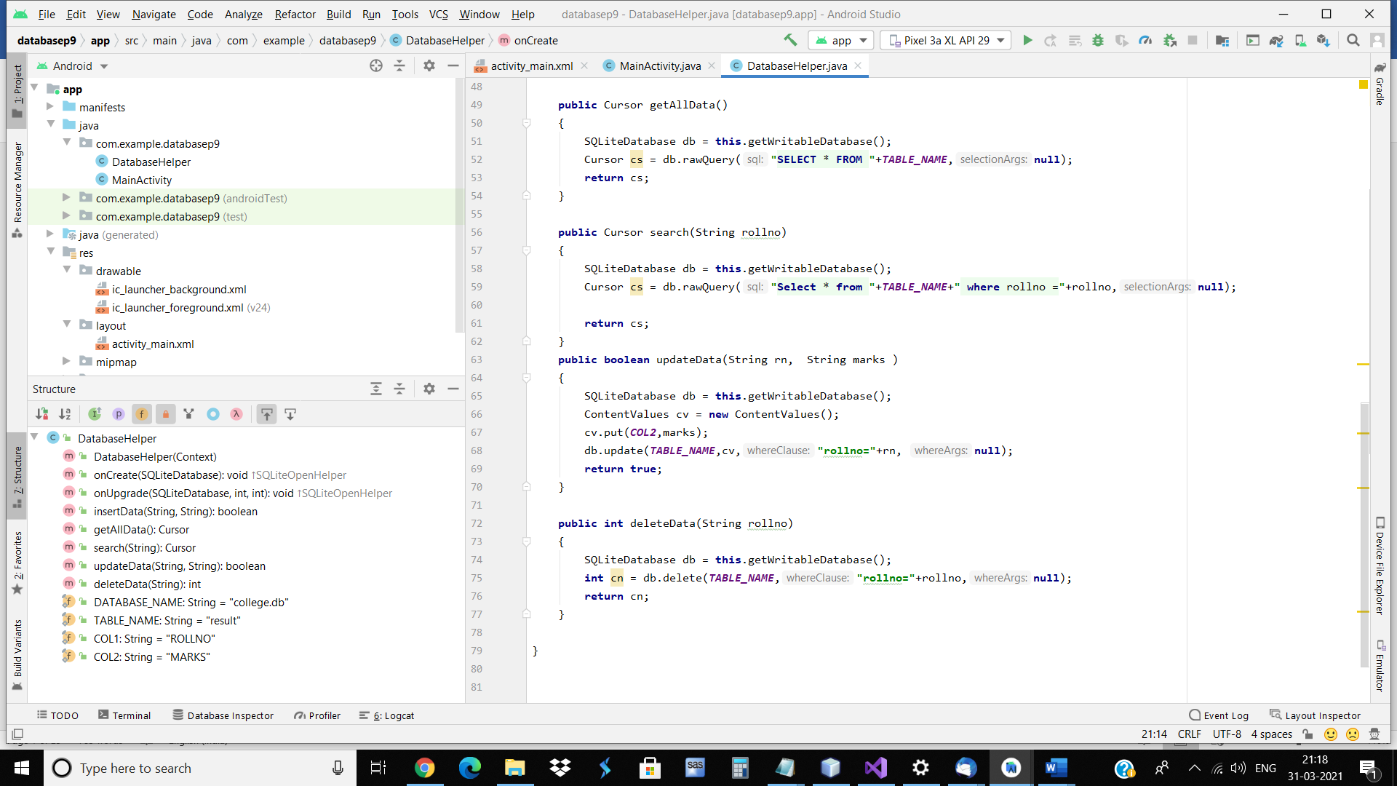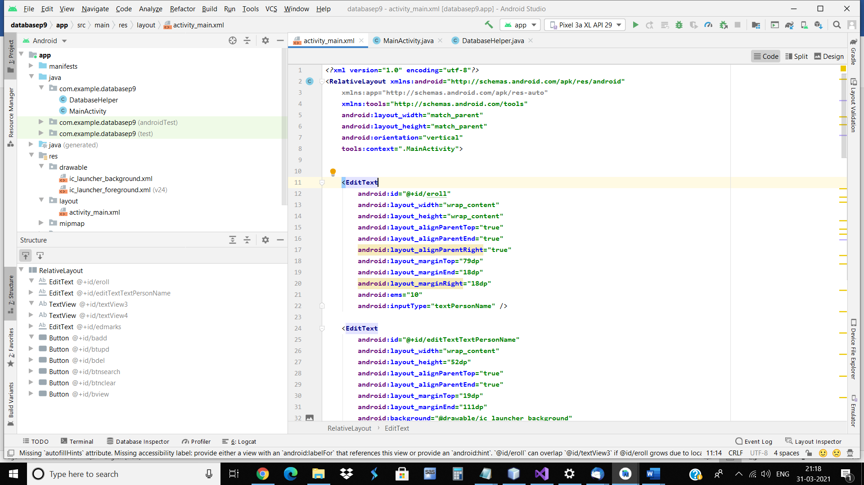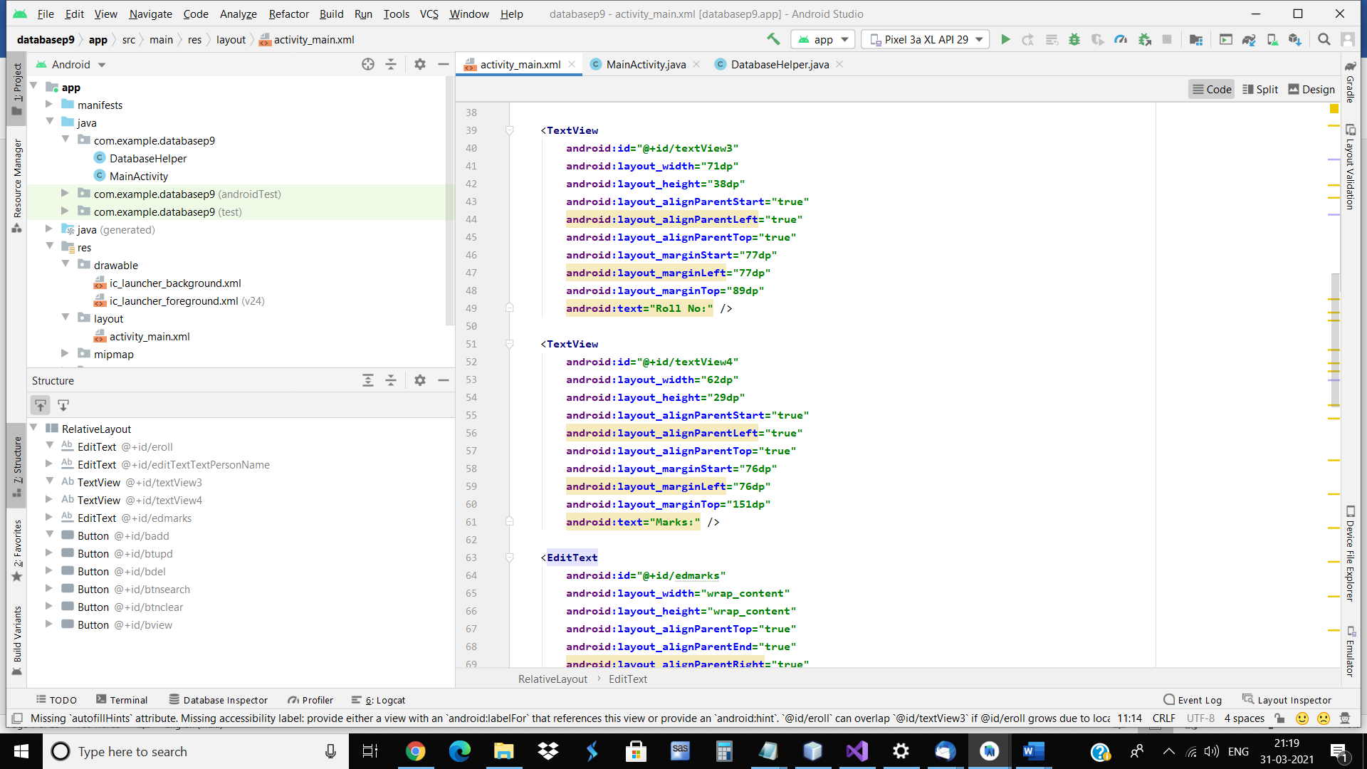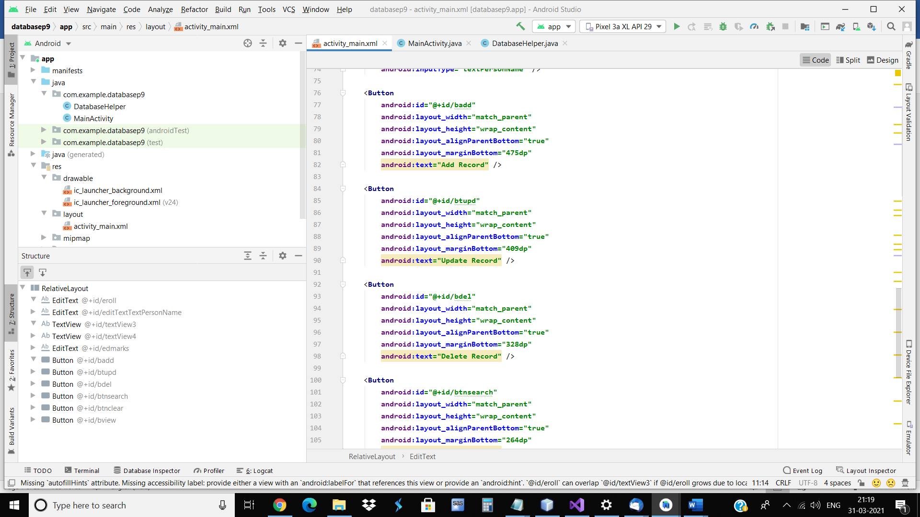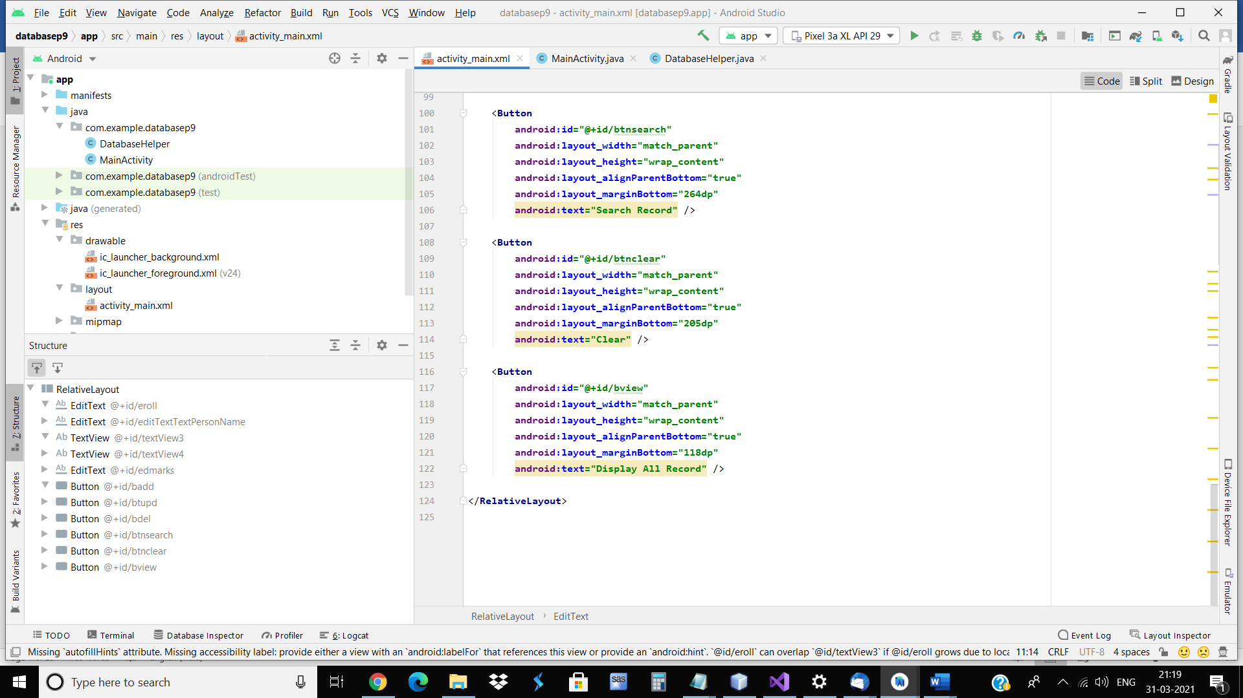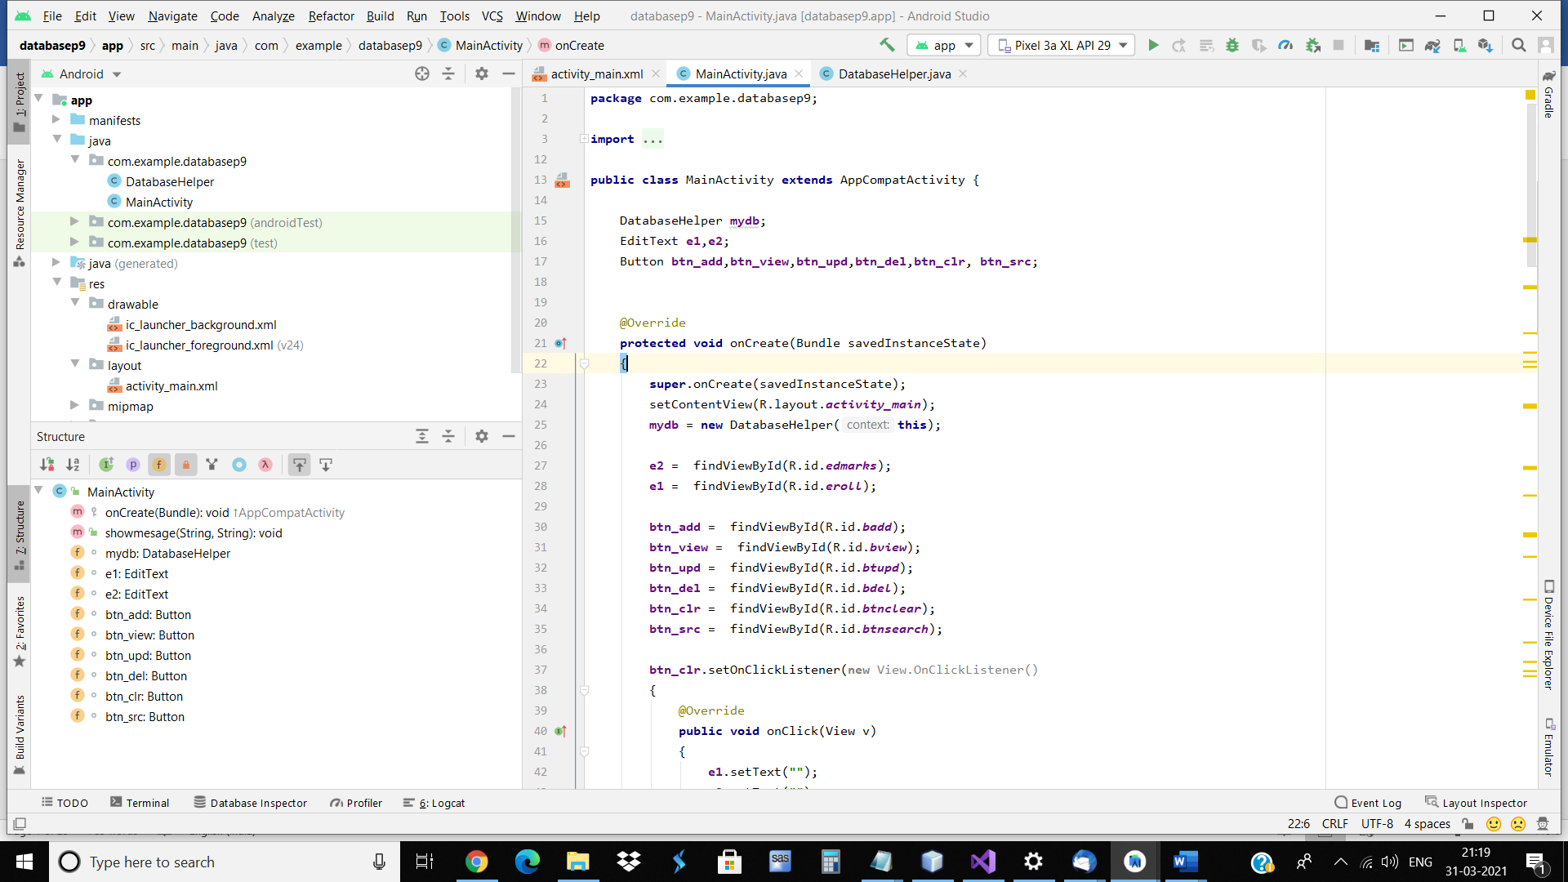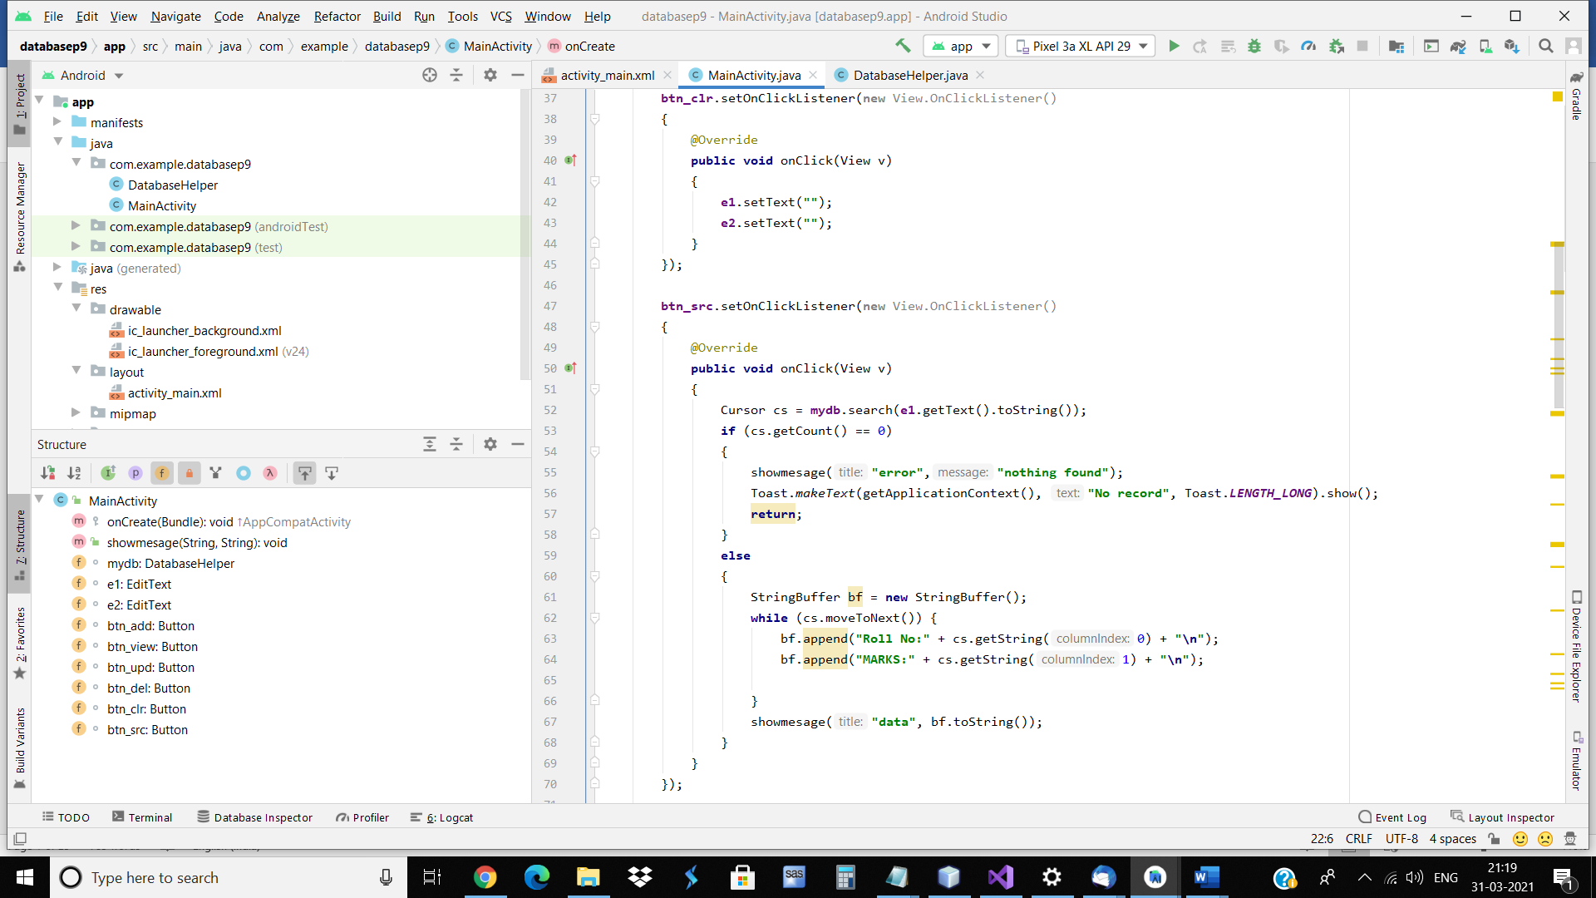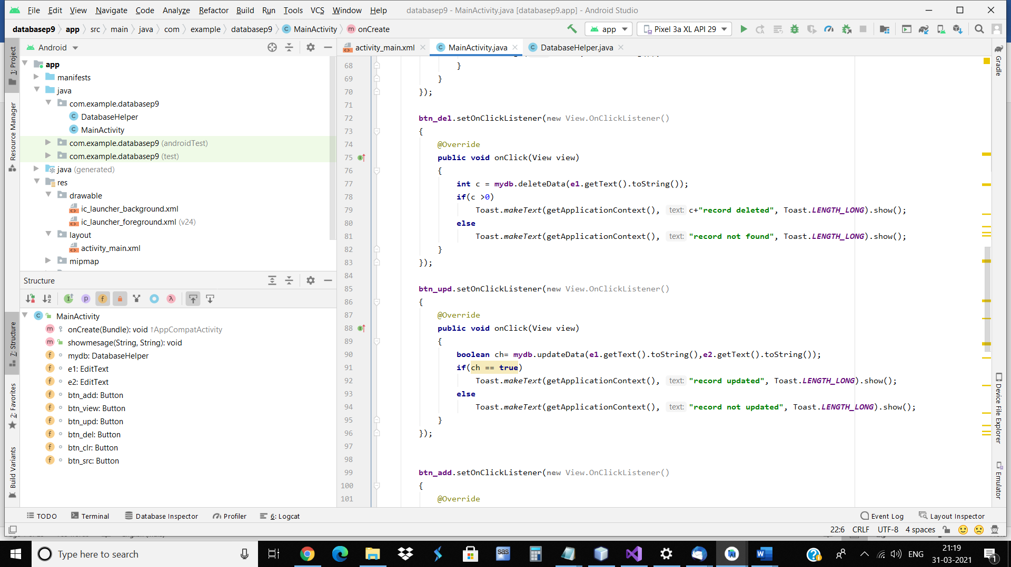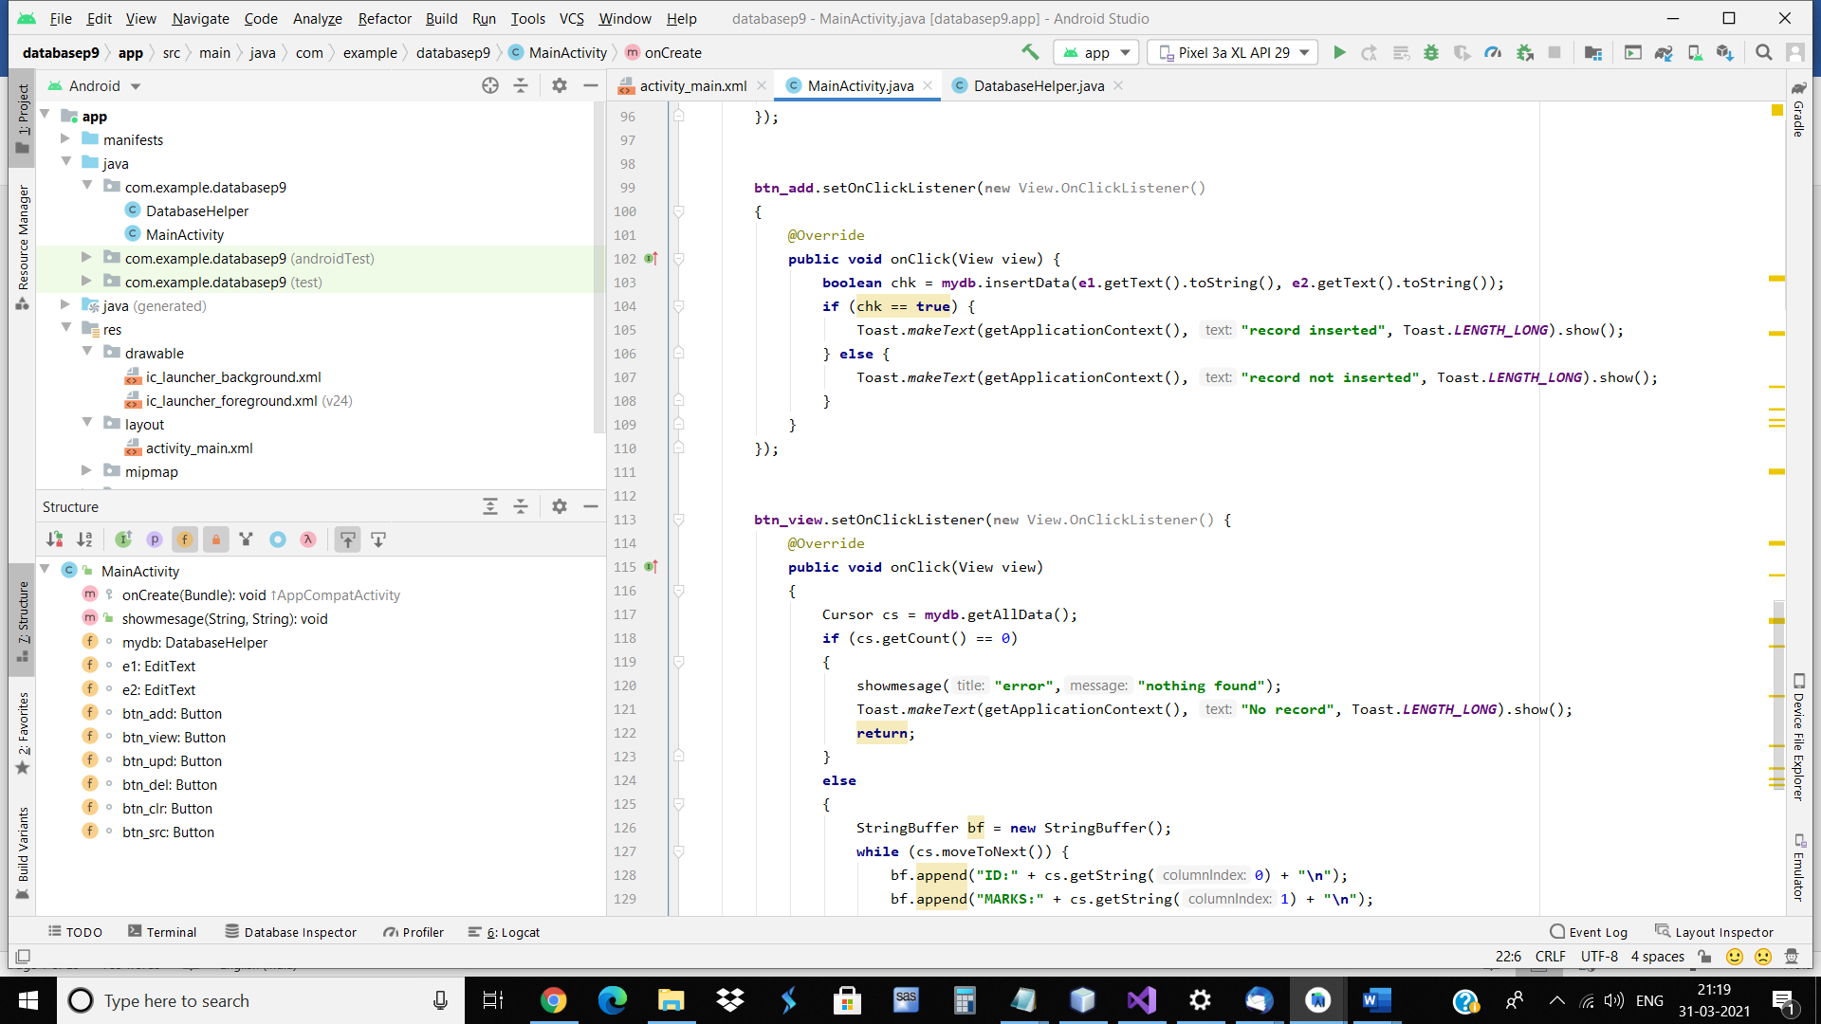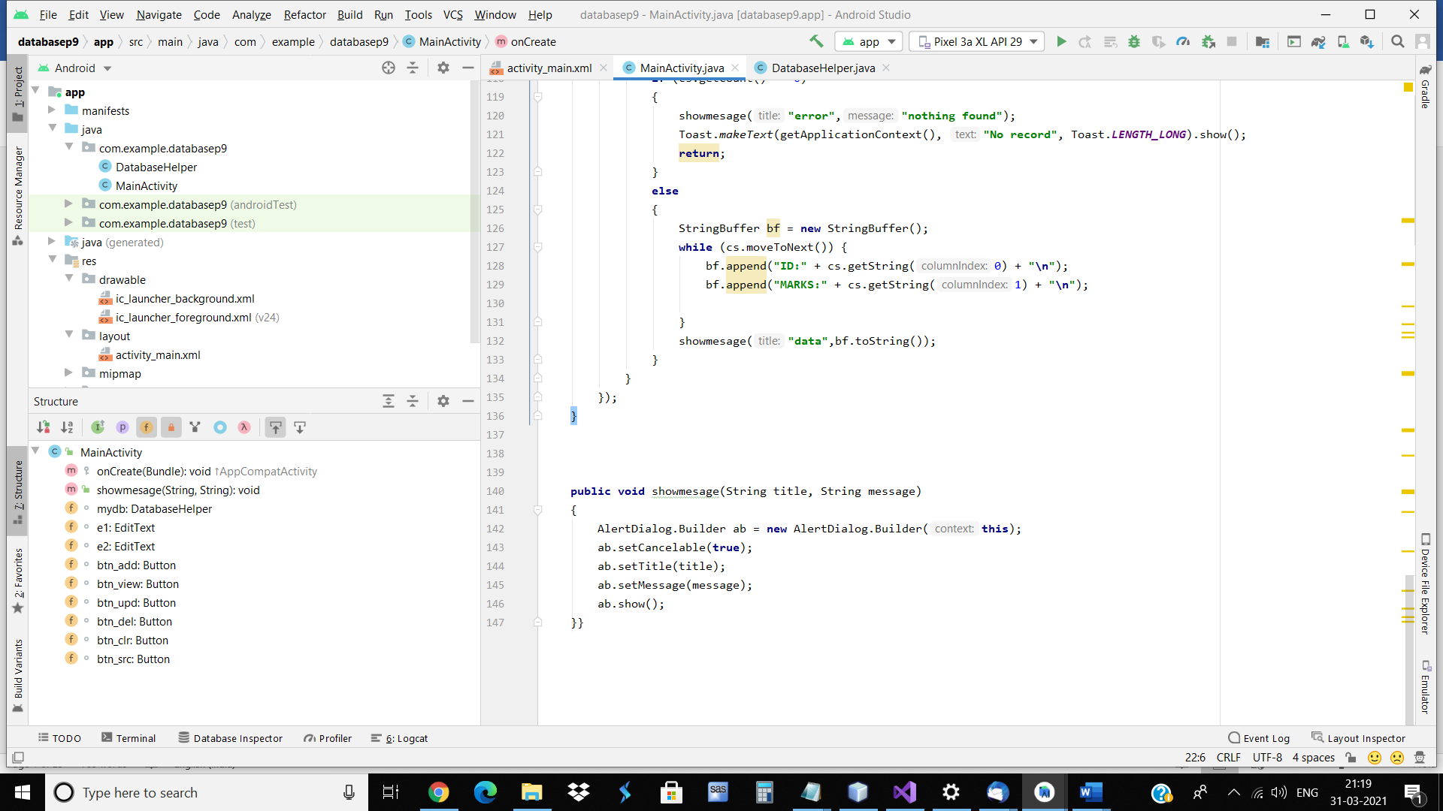

Prac10:Create an android app to demonstrate App Bar

<?xml version="1.0" encoding="utf-8"?>

<RelativeLayout xmlns:android="http://schemas.android.com/apk/res/android"

xmlns:app="http://schemas.android.com/apk/res-auto"

xmlns:tools="http://schemas.android.com/tools"

android:layout_width="match_parent"

android:layout_height="match_parent"

tools:context=".MainActivity">

</RelativeLayout>

<?xml version="1.0" encoding="utf-8"?>

<menu xmlns:android="http://schemas.android.com/apk/res/android"

xmlns:app="http://schemas.android.com/apk/res-auto">

xmlns:app="http://schemas.android.com/apk/res-auto">

<item

android:id="@+id/m1add"

app:showAsAction="always"

android:icon="@android:drawable/ic_menu_add"

android:title="add" />

<item

android:id="@+id/m2reset"

app:showAsAction="always"

android:icon="@android:drawable/ic_menu_revert"

android:title="reset" />

<item

android:id="@+id/m3about"

app:showAsAction="never"

android:icon="@android:drawable/ic_menu_info_details"

android:title="about" />

<item

android:id="@+id/m4exit"

app:showAsAction="never"

android:icon="@android:drawable/ic_menu_close_clear_cancel"

android:title="exit" />

</menu>

package com.example.appbarp10;

import androidx.annotation.NonNull;

import androidx.appcompat.app.AppCompatActivity;

import android.graphics.Color;

import android.os.Bundle;

import android.view.Menu;

import android.view.MenuInflater;

import android.view.MenuItem;

import android.widget.Toast;

public class MainActivity extends AppCompatActivity {

@Override

protected void onCreate(Bundle savedInstanceState) {

super.onCreate(savedInstanceState);

setContentView(R.layout.activity_main);

}

@Override

public boolean onCreateOptionsMenu(Menu menu) {

MenuInflater inflater = getMenuInflater();

inflater.inflate(R.menu.mymenu, menu);

return true;

}

@Override

public boolean onOptionsItemSelected(@NonNull MenuItem item) {

// Handle item selection

switch (item.getItemId()) {

case R.id.m1add:

Toast.makeText(getApplicationContext(), "Add", Toast.LENGTH_LONG).show();

return true;

case R.id.m2reset:

Toast.makeText(getApplicationContext(), "Reset", Toast.LENGTH_LONG).show();

return true;

case R.id.m3about:

Toast.makeText(getApplicationContext(), "About", Toast.LENGTH_LONG).show();

return true;

case R.id.m4exit:

Toast.makeText(getApplicationContext(), "Exit", Toast.LENGTH_LONG).show();

return true;

default:

return super.onOptionsItemSelected(item);

}

}

}

